RURAL MUNICIPALITY OF LAJORD NO. 128

PUBLIC NOTICE

Pursuant to The Planning and Development Act, 2007. Public notice is hereby given that the Council of the Rural Municipality of Lajord No. 128 intends to consider adopting bylaws to amend Bylaw No. 292 known as the Official Community Plan and Bylaw No. 293, known as the Zoning Bylaw.

BYLAW 2020-01: OFFICIAL COMMUNITY PLAN
INTENT
The proposed bylaw will add Contract Zoning as an implementation tool to the Official Community Plan. The proposed bylaw will also amend the Future Land Use Map to be consistent with the Zoning Bylaw.
AFFECTED LAND
The affected land will be designated Commercial on the Future Land Use Map: NW ¼ Sec. 8 – Twp. 15 – Rge. 16 – W2Mer. Ext. 2; NE ¼ Sec. 8 – Twp. 15 – Rge. 16 – W2Mer. Ext. 3; and, SE ¼ Sec. 8 – Twp. 15 – Rge. 16 – W2Mer. Ext. 12 shown on the attached map dated August 10, 2020.

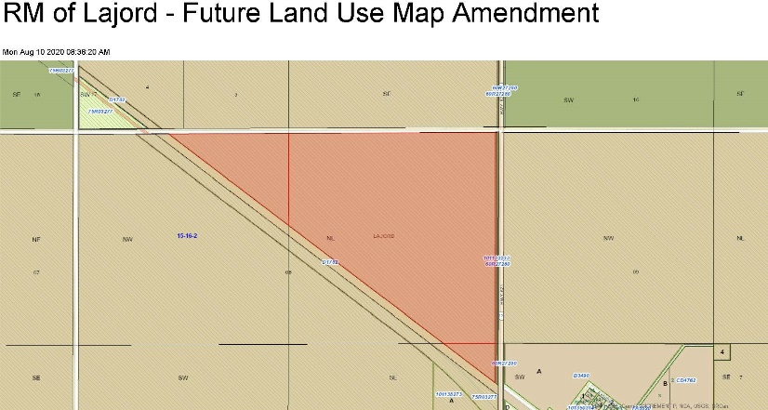

REASON
The reason is to allow the RM to enter into Contract Zones to accommodate future developments that include unique elements, unique land/ownership structure, a specific development proposal, or require a distinct set of development standards. The Future Land Use Map is to be amended to be consistent with a previous amendment to the Zoning Bylaw whereby the affected lands were rezoned from Agricultural to Commercial.

BYLAW 2020-07: ZONING BYLAW
INTENT
The proposed bylaw will include “Grain Terminal Infrastructure, Fertilizer Terminal Infrastructure, Grain on/off loading, Fertilizer on/off loading, Agricultural Primary Processing, Agricultural Secondary Processing, Agricultural Biomass Processing, Agricultural Biomass Drying & Storage” as discretionary uses in the zoning district - COMMERCIAL DISTRICT (C) and include revisions and development standards that align with surface bare land condominiums.
AFFECTED LAND
The affected land will be all lands within the COMMERCIAL DISTRICT (C) which includes the: NW ¼ Sec. 8 – Twp. 15 – Rge. 16 – W2Mer. Ext. 2; NE ¼ Sec. 8 – Twp. 15 – Rge. 16 – W2Mer. Ext. 3; and, SE ¼ Sec. 8 – Twp. 15 – Rge. 16 – W2Mer. Ext. 12.

REASON
The reason for the amendment is to provide for the development of a Grain Terminal Facility and related land uses within a Surface Bare Land Condominium.

PUBLIC INSPECTION
The proposed bylaws may be inspected by any person or group at the office of the administrator. Copies of the Bylaw are available at request.

PUBLIC HEARING
Council will hold a public hearing at 9:00 am, on Tuesday September 8, 2020 via the Zoom video communication application to hear any person or group that wants to comment on the proposed bylaws. A link will be provided on the RM of Lajord’s website (https://rmlajord.ca/) for access to the hearing. Due to the current situation if you wish to comment on the bylaws Council prefers that all comments be provided by written submission. This ensures that if there are any technical difficulties during the Public Hearing your comments will be heard. If you wish to provide a written submission please contact the RM office no later than 3:00 pm on September 4, 2020 or by email at rm128@sasktel.net to provide a submission.

Issued at the RM of Lajord No. 128 this August 14, 2020.

Lynette Herauf Rural Municipality of Lajord, No. 128
Administrator Box 36
Lajord SK S0G 2V0

